NAME: Preksha Jain

SAP ID: 500120166

BATCH: 1

**EXPERIMENT 8 and 9**

Experiment8:

**Title: Use of different SQL clauses and join**

**Objective:** To understand the use of group by and having clause and execute the SQL commands using JOIN

1.Consider the following schema:

Student (sid, sname, age)

Match (mid, mname, venue)

Play (sid, mid, day(date))

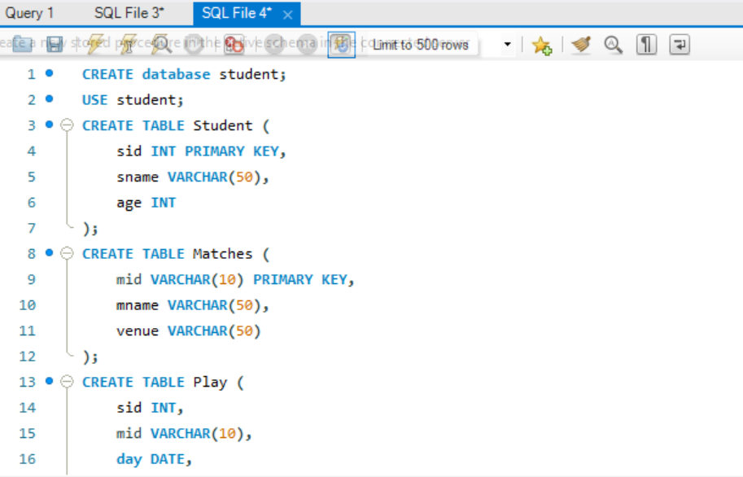

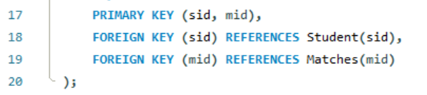

1. Populate all the tables.

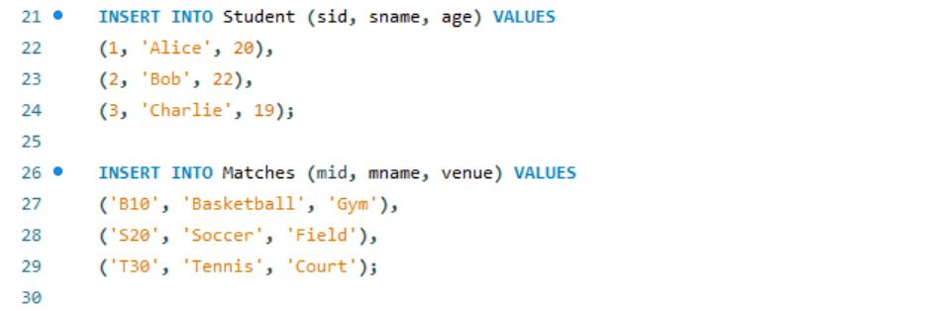

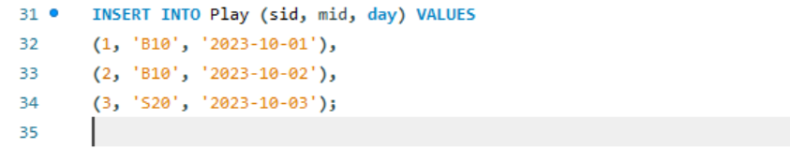

1. Find all information of students who have played match number B10.

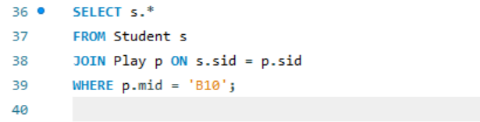

1. Find the name of matches played by Amit.

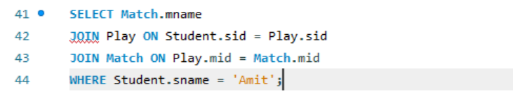

1. Find the names of students who have played a match in Delhi.

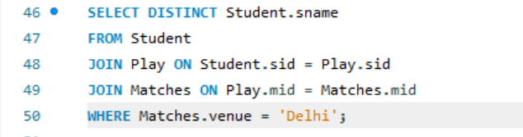

1. Find the names of students who have played at least one match

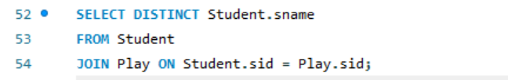

1. Find the ids and names of students who have played two different matches on the same day.

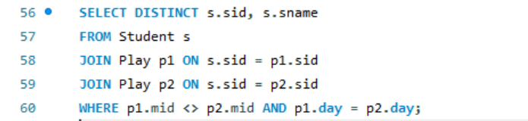

1. Find the ids of students who have played a match in Delhi or Mumbai

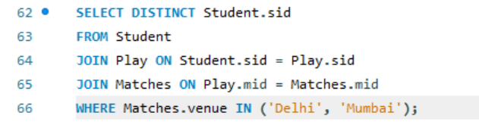

1. Find the average age of students.

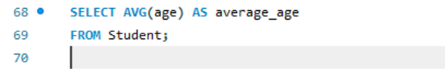

Experiment 9:

* 1. Create table of table name: EMPLOYEES and add 6 rows

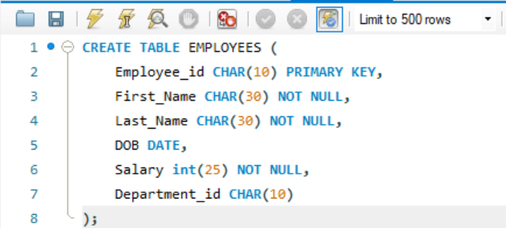

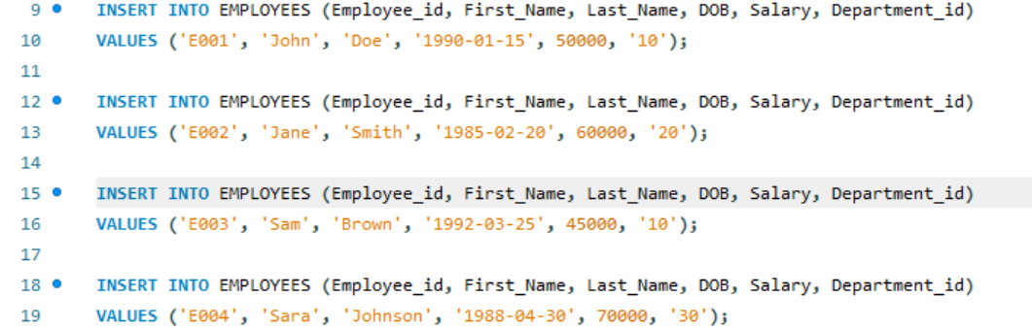

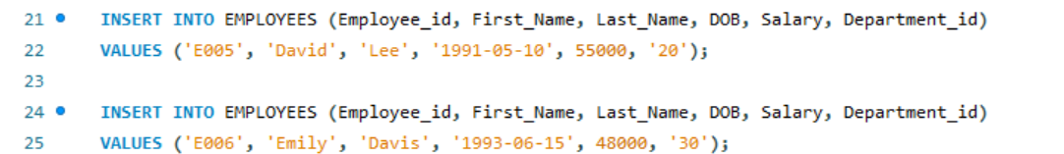

**2. Execute the following view related queries:**

1. Create View of name emp_view and the column would be Employee_id, Last_Name, salary and department_id only.



1. Insert values into view(remove the NOT NULL constraint and then insert values):

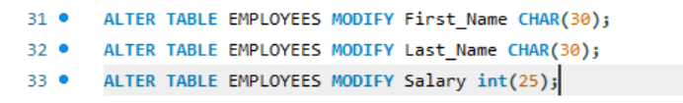



1. Modify, delete and drop operations are performed on view.

Modify:



Delete:

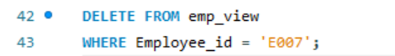

Drop:

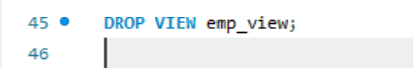

1. Creates a view  named salary_view. The view shows the employees in department 20 and their annual salary.

